Order Status
The Order Status screen initially opens with order search options for:
- Part Number
- Order Date
- Dealer PO
- Invoice ID
- Order ID
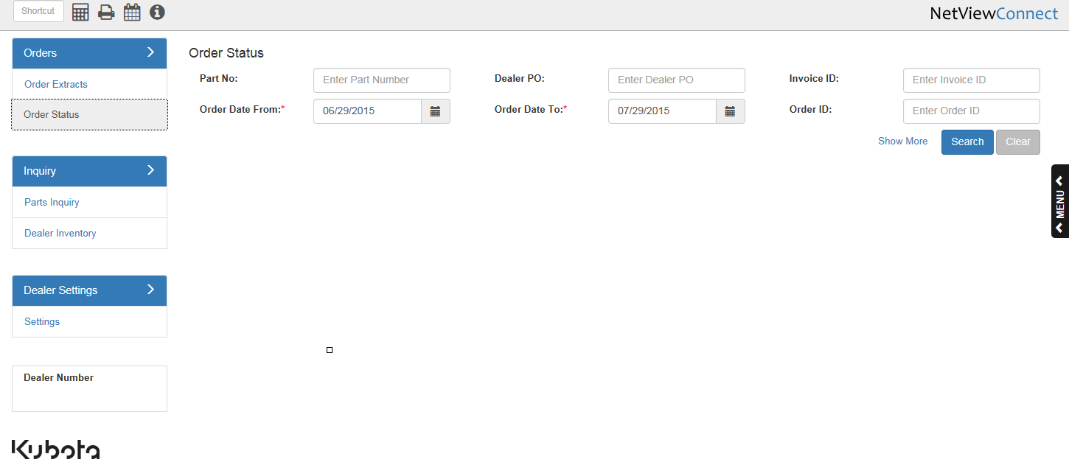
Show More: Click on “Show More” to enhance the search options to include:
- Order Type
- Ship Date
- Warehouse
- Status
- Ship Via
- Tracking Number
